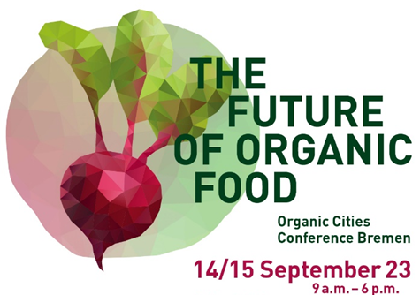
Organic Cities Conference Bremen:
The Future of Organic Food

Registration Form
Please complete the registration form and send it to biostadt@umwelt.bremen.de
by 14 August 2023.
First Name: | Last Name:
Email:
Organization: | Country of Travel:

Workshop Selection
Please indicate which of the following workshops you would like to participate in by marking "X" in the corresponding box (please choose one):
☐ Workshop 1 (English): Changing food systems - moving the lever of organic communal catering
☐ Workshop 2 (German): Transition Arena: Shaping the Food Revolution
☐ Workshop 3 (German): Regional Value Chains: Regional Logistics as a “missing link”
☐ Workshop 4 (German): Role of Cities in the Transformation of Our Food System

City Walking Tour
Would you like to join us for a walking city tour after the event at 6:30 pm, heading towards the dinner location?
☐ Yes, I would like to participate in the walking city tour.
☐ German guided tour
☐ English guided tour
☐ No, I do not wish to participate in the walking city tour.
Note: It is also possible go to the dinner location by public transport.

Organic Dinner
After the city tour, we invite you to join us for a seasonal organic dinner at 8 pm. Please note that the cost of the dinner (25 €) and drinks will be at your own expense.
☐ I would like to attend the organic dinner.
☐ I do not wish to attend the organic dinner.
Please indicate any food restrictions:

Field Trip
In the morning of 15 September, we offer two exciting excursions. Please indicate which field trip you would like to participate in:
☐ Field Trip 1 (Bicycle tour through Bremen Überseestadt incl. a lunch snack)
☐ Field Trip 2 (Bus tour of Bremen´s agriculture incl. a lunch snack)
☐ No, I will be attending on 14 September 2023 only.

Hotel Accommodation
We have reserved a hotel contingents for you under the keyword "Organic Cities" at the following hotel:
Please be aware that hotel accommodations are at your own expense.
B&B Hotel Bremen-Überseestadt (Hansator 15, 28217 Bremen)
40 rooms available until 31 August 2023
Price per room and night: 89,25 € (including breakfast)
Phone number: +49 (0) 421 56627260
To request a room, please contact the corresponding hotel directly and mention the keyword "Organic Cities."

Data Processing Consent
☐ I consent to the processing of personal data.
We are looking forward to your participation!

